MyView Display Function – CGEA 1.3

Functional Description

The MyView Display Function gives the driver the ability to choose a subset of on-demand screens to display in the MyView tab as well as the ability to reorder these screens. The driver interfaces and controls the displayed information via the five-way message center switch (UP, DOWN, LEFT, RIGHT, and OK) that is located on the left hand side of the steering wheel.

This STSS should be treated as a supplement to the “Message Center – SHMI Displays with 5 Button Interface – CGEA 1.3” specification, and is intended for use in 4.2" LCD or similar displays with a tabbed view (e.g., P552 L2 clusters).

Note: the “Configure MyView” on-demand screen should always be the last item in the MyView list and cannot be removed from the list.

Interfaces

Interface Context Diagram (I/O Block Diagram)

MyView Display Function Context Diagram

Inputs

IR-REQ-346316/A-INTERNAL:
- Operational_Mode
- MC Switch (UP, DOWN, LEFT, RIGHT, and OK)
- M/C_Display_Status
- Advanced_Setup, see “Message Center – SHMI Displays with 5 Button Interface – CGEA 1.3” specification

IR-REQ-346317/A-Outputs

- MyView_X_MC (X = 1, 2, 3, … CurrentNumOfGraphics, … MaxNumOfGraphics)
- TooManyMyViewGraphics_MC_Status_Flag
- Message_Center_Informational_Chime_Status_Flag

Function/Performance

F-REQ-346318/A-Operational Modes

Operating Mode | Functionality Based on Operating Mode
Sleep Mode | OFF
Limited Mode | OFF / Welcome/Farewell / Limited Warning Functionality
Normal Mode | Full Functionality
Crank Mode | Full Functionality

Voltage Levels

Refer to the Cluster Feature table located in the Operational Modes and Voltage Range section in this STSS.

Human-Machine Interface

Visual

Note: Graphics are for example purposes only. Refer to program specific graphics library.

MyView Sample Graphics
Sample Graphic | Comments
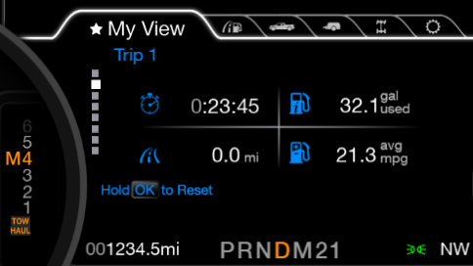 | Top-level MyView screen displaying the “Trip 1” graphic in the second position.  In other words, MyView_X_MC = Trip 1, where X = 2.
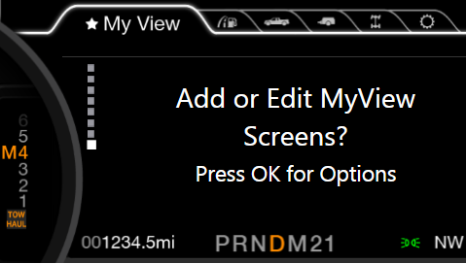 | Top-level MyView screen displaying on-demand “Configure MyView” graphic in the last position.  In other words, MyView_X_MC = Configure MyView, where X = 8.
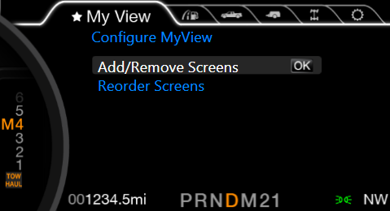 | “Configure MyView” screen.
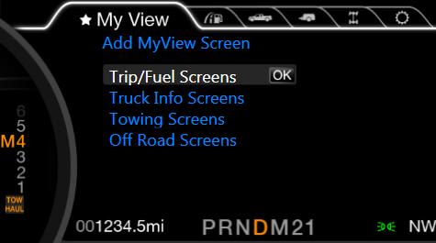 | “Add MyView Screen” screen.
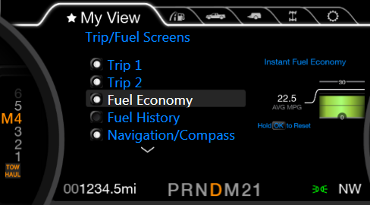 | “Trip/Fuel Screens”, which is a sub-menu of the “Add MyView Screen” menu.  A check-box indicates that a certain graphic is included in the MyView list of on-demand screens.  Note the graphic to the right of the highlighted item is a smaller version of the graphic relating to the highlighted item.
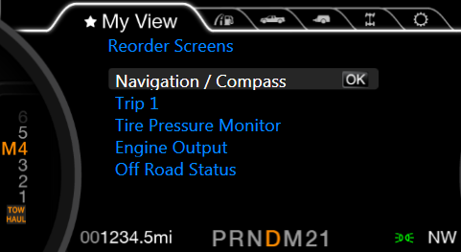 | “Reorder Screens” before selecting a graphic to reorder.  Note the graphic to the right of the highlighted item is an “OK” graphic.
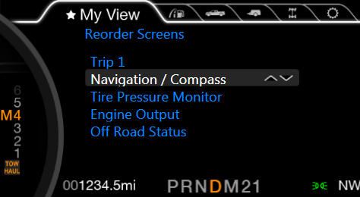 | “Reorder Screens” after selecting a graphic to reorder.  Note the graphic to the right of the highlighted item is an up/down arrow graphic.
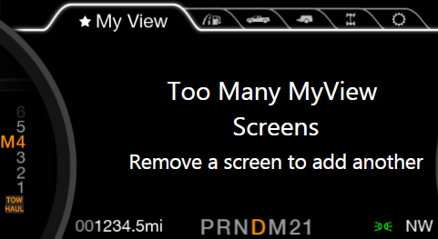 | Warning message displayed when the driver attempts to add one too many screens to MyView.

Indicator Graphics / Display Format

Refer to “<Program> Cluster Menu Structure.xls” and Program VAPS Model.

Sample Display Format Based on HMI Menu Structure and Default MyView Selections
Main Menu  level 1 | Menu  level 2 | Menu  level 3 | Menu  level 4 | Menu  level 5
MyView | Graphic 1, 2, … n*
MyView | Configure MyView | Add/Remove MyView Screens | Trip/Fuel Screens | Trip 1  Trip 2  Fuel Economy  Fuel History  Navigation/Compass  Average Speed  Auto StartStop
MyView | Configure MyView | Add/Remove MyView Screens | Truck Info Screens | Gauge Selection  Tire Pressure  Engine Output  Engine Information  MyKey Status
MyView | Configure MyView | Add/Remove MyView Screens | Towing Screens | Trailer Info  Trailer Status  Tow Information
MyView | Configure MyView | Add/Remove MyView Screens | Off Road Screens | Pitch and Roll  ControlTrac 4WD
MyView | Configure MyView | Reorder Screens | Trip 1
MyView | Configure MyView | Reorder Screens | Fuel Economy
MyView | Configure MyView | Reorder Screens | Tire Pressure
MyView | Configure MyView | Reorder Screens | Pitch and Roll
MyView | Configure MyView | Reorder Screens | Graphic n Name
*Note: n = CurrentNumOfGraphics - 1, where CurrentNumOfGraphics is defined in Section 1.3.5.4.

Indicator Color Coordinates

Refer to program specific HMI requirements.

Audio

See Message Center Chime STSS module and Chime Arbitrator STSS module.
W2111 is associated with Message_Center_Informational_Chime_Status_Flag

Switch Control Logic

See “Message Center – SHMI Displays with 5 Button Interface – CGEA 1.3” specification and Section 1.3.5.

PFM-REQ-346319/A-System Accuracy

Within a 100msec of receiving a message that results in a change of state the cluster will update the display to the proper status.

Operation: Performance and Functional

Subsystem Algorithm Flowcharts / State Diagrams

F-REQ-346320/A-MyView Add/Remove Graphic Flowchart

F-REQ-346321/A-MyView Reorder Graphics Flowchart

Operation Description (supports algorithm flowchart / state diagram)

F-REQ-346322/A-MC Warning Flag to Warning ID Table

Flag | Warning ID | Active Chime_Status_Flag
TooManyMyViewGraphics_MC_Status_Flag = ACTIVE | W2111 | Message_Center_Informational  _Chime_Status_Flag

F-REQ-346323/A-MyView Display Function Description
- The MyView Display Function gives the driver the ability to choose a subset of on-demand screens to display in the MyView tab as well as the ability to reorder these screens.

F-REQ-346324/A-MyView Display Function Supplier DID
- The maximum number of graphics that MyView should display is configurable via a parameter in supplier DID $FDXX. The range includes 5 to 10 graphics (including the Configure MyView graphic).

F-REQ-346325/A-MyView Display Function Defaults
    - The MyView tab is prepopulated with four default graphics in addition to the setup graphic. They are as follows (in order):

- Trip 1
- Instantaneous Fuel Economy
- Tire Pressure
- Off Road Screen
- Configure MyView

These graphics, with the exception of the Configure MyView graphic, can be reordered or removed by the driver.

F-REQ-346326/A-MyView Display Function Maximum Number of Graphics
- When configuring MyView, the driver can add up to the maximum number of graphics minus 1 (to protect for the Configure MyView graphic). If one too many screens is added, a popup message will occur.

F-REQ-346327/A-MyView Display Function Memory Storage
- The driver’s selected MyView graphics and the order of these graphics shall be remembered at battery disconnect and should be restored upon a battery reconnect.

F-REQ-346328/A-MyView Display Function Screen Reorder
    - In order to reorder screens, an item must be selected via the “OK” button pressed. Once “OK” is pressed, the item will show and up/down arrow on the right side indicating that an item can be moved up and down in the list. The reordering process is complete after pressing “OK” or L_CursorLeft_Switch. At this point, the up/down arrows go away and “OK” appears again.

Note that a small graphic is shown next to the items in the add/delete list to illustrate which screen would be added or removed from the MyView tab.

F-REQ-346329/A-MyView Display Function Last Shown Screen
- MyView will also have a memory feature similar to other tabs. Upon moving away from the MyView tab to another tab, the cluster will remember which MyView screen was last shown and will return to this screen upon returning to the MyView tab.

FS-REQ-346333/A- Function Safety Classification (EMC)

Class B.

Memory Storage

NVM-REQ-346330/A-Memory Storage Table:

Parameter Name | Description | Value at  Battery Connect | Value at  Module Wake-up
Advanced_Setup | Internal flag used to determine if the Advanced Settings menu, and advanced MyView functions are available. See “Message Center – SHMI Displays with 5 Button Interface – CGEA 1.3” specification. | FALSE (0x0) | FALSE (0x0)
CurrentNumOfGraphics | Internal variable (integer) to keep track of the current number of graphics shown in MyView. This includes the Configure MyView graphic. | Do Not Init,  See * Below | Do Not Init,  See * Below
M/C_Display_Status | State indicator to identify which text is currently being displayed on Message Center display. See * | See ** Below | See ** Below
MyViewReorder_Flag | Internal flag to determine if the MyView Reorder sub-function is in the process of rearranging the order of the screens in MyView. | FALSE (0x0) | FALSE (0x0)
MyView_X_MC | Internal parameter used to keep track of which on-demand screens should be shown in the MyView tab and the order of these screens. X = 1, 2, … CurrentNumOfGraphics, … MaxNumOfGraphics at most. | Do Not Init,  See * Below | Do Not Init,  See * Below
Message_Center_Informational_  Chime_Status_Flag | Used to control the state of the chime to the Chime Arbitrator | Inactive | Inactive
Operational_Mode | 4 state indicator for cluster operational mode. | Limited | Limited, Normal or Crank
*Note: The selected MyView on-demand screens and the order of these screens should be stored in EEPROM in order for this information to be recalled after a battery disconnect/reconnect.

**Note: Refer to Message Center X Display_Y Button Interface Section, where X and Y are appropriate values in this document.

NVM-REQ-346331/A-Memory Supplier DID:

Parameter Name | Description | Value at  Battery Connect | Value at  Module Wake-up
MaxNumOfGraphics | Internal parameter based on supplier DID $FDXX: Max Number of MyView Graphics. This parameter controls the maximum number of graphics that can be displayed in the MyView screen, including the Configure MyView graphic. See Section 1.5.3. | Do Not Init | Do Not Init

Prove Out

Not applicable.

Reconfigurable Telltale

Not applicable.

Message Center Message

See “Message Center – SHMI Displays with 5 Button Interface – CGEA 1.3” specification.

Error Handling

Missing Message Strategy

The signals will be declared missing as per the Diagnostics section of this STSS.

DTCs states and history will be determined as per the Diagnostics section of this STSS.

Diagnostics

Self-Test

None.

Engineering Test Mode

Reference section “Dealer / Engineering Test Mode (ETM)”.

Part II Performance

Supported Diagnostic Trouble Codes (DTCs)

No DTCs shall be logged due to this feature.

DCR-REQ-346332/A-Supported Diagnostic DIDs (Service $22)

Block | DID / Common ID Name | PID Type | Default | Min | Max | Description
$FDXX | Max Number of MyView Graphics | Integer | 8 (0x8) | 5 (0x5) | 10 (0xA) | Supplier DID to control the maximum number of graphics present in the MyView screen, including the Configure MyView graphic.

Reference Specifications

IS-0001 WARNINGS/INDICATORS/DISPLAYS PROVEOUT
IS-0052 OPERATING VOLTAGES - FUNCTIONAL/PERFORMANCE
IS-0069 FUNCTIONAL IMPORTANCE CLASS
IS-0324 WINDSHIELD & OTHER REFLECTIONS
IS-0327 WARNING INDICATOR EVALUATION
IS-0379 NORTH AMERICAN WARNINGS AND INDICATORS STRATEGY

IL-0019 GENERAL ILLUMINATION DIMMING
IL-0021 CRAFTSMANSHIP - DISPLAYS
IL-0022 GENERAL ILLUMINTATION COLOR
IL-0023 CLARITY/LEGIBILITY/READABILITY
IL-0025 INTERIOR ILLUMINATION INTENSITY
IL-0027 VISUAL CONTRAST
IL-0043 OPERATIONAL ENVIRONMENT FUNCTIONALITY
IL-0045 COLOR
IL-0048 ILLUMINATION ACCEPTABILITY

03-0661 PLACEMENT: CONTROL AND DISPLAY LOCATIONS
03-0662 PLACEMENT: LOGICAL GROUPING FUNCTION AND USAGE
03-0664 PLACEMENT: DOWN VISION TO COMPONENTS WITH HIGH VISUAL DEMAND
03-0665 PLACEMENT: EXPECTED LOCATIONS OF CONTROLS AND DISPLAYS VDS
03-0670 INTERIOR VISIBILITY
03-0671 INTERIOR VISIBILITY: REFLECTIONS FROM COMPONENTS & SURFACES
03-0672 INTERIOR VISIBILITY: REFLECTIONS IN DISPLAYS
03-0673 INTERIOR VISIBILITY: VISUAL OBSCURATIONS
03-0674 INTERIOR VISIBILITY: ILLUMINATION CONTROLS / DISPLAYS
03-0675 INTERIOR VISIBILITY: VEILING GLARE
03-0677 INTERIOR VISIBILITY: SUNLIGHT WASHOUT
03-0681 IDENTIFICATION: CHARACTER AND SYMBOL SIZE
03-0682 IDENTIFICATION: LEGIBILITY
03-0685 IDENTIFICATION: SYMBOLS, ABBREV FOR CONTROL
03-0721 LOGIC OF OPERATION: OPERATIONAL STEREOTYPES
03-0722 LOGIC OF OPERATION: INTERPRETATION
03-0723 LOGIC OF OPERATION: USE OF SYSTEMS WITH VISUAL DISPLAYS

Revision History
STSS Module Revision History

Revision | Name | Change Description | Date
1.0 | M. Ehlert | Initial release based on “P552 L2 Cluster Logic of Operation” document and P552 L2 cluster model. | 11/14/2012
1.1 | A. Venuturupalli  S. Watkins | Removed bullet point “MyView is strictly a graphical view of screens, unlike the other tabs that have a list of items in the root of the tab” in Section 1.3.5.2 per Denso P558 MY17 Q&A #644 | 3/17/2015
1.2 | Ilopezla | This update adds the Chime_Status_Flag associated with Warning ID W2111 as per Global_Msg_List_ver32_Released_6_24_2015  Section 1.2.1 Figure 1 Added Message_Center_Informational_Chime_Status_Flag  Section 1.2.3 Added Warning ID and Message_Center_Informational_Chime_Status_Flag  Added Table Reference (hyperlink)  Section 1.3.3.3 – Added Message_Center_Informational_Chime_Status_Flag  Section 1.3.5.2 Updated Table 1.2  Changed column’s header from Chime to Active Chime_Status_Flag  Added Message_Center_Informational_Chime_Status_Flag  Section 1.3.5.4 Added Message_Center_Informational_Chime_Status_Flag rows | 11/30/2016
1.3 | S. Watkins | Initial VSEM RM release | 3/1/2019

